

COGNIZANT

(ES-456: Internship Report)

submitted in partial fulfillment of the requirement for the award of the degree of

Bachelor of Technology in
Computer Science & Engineering

Submitted by ARUNIMA NEGI
04715002722

Under the supervision of Dr. SHALU

Assistant Professor

Maharaja Surajmal Institute of Technology

(Affiliated to Guru Gobind Singh Indraprastha Universuty) Janakpuri, New Delhi-58

May 2026

DECLARATION

This is to certify that the material embodied in this internship report titled “ Cognizant ” being submitted in the partial fulfillment of the requirements for the award of the degree of Bachelor of Technology in Computer Science & Engineering is based on my original work. It is further certified that this internship work has not been submitted in full or in part to this university or any other university for the award of any other degree or diploma. My indebtedness to other works has been duly acknowledged at the relevant places.

(Arunima Negi)
04715002722

CERTIFICATE FROM THE COMPANY

This is to certify that ARUNIMA NEGI (Enrollment No. 04715002722) has undertaken internship at Cognizant ( Acerox Saastech Pvt Ltd ), 5/535, Old Mahabalipuram Road Okkiam -Thoraipakkam, Chennai, Tamil Nadu 600096 from 31/01/2026 to 13/05/2026 under the supervision and guidance of Mr. Mohan Jayabal, Manager.

(Mohan Jayabal)
Manager QEA
Cognizant

CERTIFICATE FROM THE INSTITUTE

This is to certify that the work embodied in this Internship Report titled “ Cognizant ” being submitted in the partial fulfillment of the requirements for the award of the degree of Bachelor of Technology in Computer Science & Engineering, is original and has been carried out by ARUNIMA NEGI (Enrollment No. 04715002722) under my supervision and guidance.

It is further certified that this Internship work has not been submitted in full or in part to this university or any other university for the award of any other degree or diploma to the best of my knowledge and belief.

Ms. Shalu Dr. Sapna Malik
Assistant Professor Assistant Professor
( Faculty Supervisor ) ( Internship Coordinator )

Dr. Geetika Dhand
HOD
Maharaja Surajmal Institute of Technology

ACKNOWLEDGEMENT

First and foremost, I would like to express my deepest gratitude to the Almighty for granting me the strength, patience, and determination to complete this endeavor.
I am sincerely thankful to my Faculty Supervisors – Dr. Shalu whose constant support, invaluable guidance, and insightful feedback have been instrumental throughout the course of this project. Their mentorship has significantly contributed to both my academic and personal growth.
My sincere thanks go to the Director of my institute Prof. (Dr.) Archana Balyan for providing a platform that supports innovation and professional development.
I would also like to thank our Head of Department (HOD) – Dr. Geetika Dhand for the academic direction and consistent encouragement provided throughout my studies.
A special note of gratitude to the Internship Coordinator Ms. Sapna Malik for facilitating opportunities that shaped this learning experience.
I am deeply grateful to the entire team at Cognizant especially my Manage, Mr. Mohan Jaybala, for welcoming me into their visionary organization. Their leadership and innovation have been a constant source of inspiration. I would also like to thank my Peers and Friends for their cooperation, encouragement, and support throughout this journey.
Last but not least, I am profoundly thankful to my Family Members whose unconditional love, support, and belief in me have been the backbone of my journey.
This acknowledgement is a small gesture of appreciation for the many individuals who played a pivotal role in the successful completion of this work. Each contribution has been deeply valued and will always be remembered with immense gratitude.

ARUNIMA NEGI
04715002722
CSE-1

ABSTRACT
This internship report documents the learning journey and professional experience gained during the Quality Engineering and Assurance (QEA) internship program conducted by Cognizant Technology Solutions under the Generation Cognizant (GenC) initiative. The internship has been completed during the span of 8th semester and comprised of three major stages: Stage 1 focused on Core Java programming with SQL, Stage 2 covered Functional Testing with Selenium Automation concepts, culminating in a Business Aligned Project and Stage 3 covered Generative AI (GitHub copilot).

The program adopted a Flipped Classroom methodology, emphasizing Learner Autonomy through structured self-paced learning, Instructor-Led Training (ILT), hands-on exercises, and code challenges on the Tekstac platform. Tools and technologies covered include Core Java, SQL, Selenium WebDriver, TestNG, Apache POI, Page Object Model (POM), BDD Cucumber, Jenkins, Maven, Git, Docker, POSTMAN, and REST Assured API Automation.

The internship provided significant exposure to Quality Assurance principles, automated testing frameworks, DevOps tools, and Agile methodologies. Through interim and final evaluations, technical interviews, and project development, the experience contributed substantially to both technical competency and professional readiness. This report details the organizational profile, internship objectives, tasks undertaken, tools used, challenges faced, contributions made, and key learnings derived from the program.

TABLE OF CONTENTS

Page No
Declaration i
Certificate from the Company ii
Certificate from the Institute iii
Acknowledgement iv
Abstract v
List of Figures vii
Chapter 1: Introduction of the Company 8
  - : About the Company 8
  - : Profile of the Company 9
Chapter 2: Introduction of the Internship 10
  - : About the Internship 10
  - : Objectives of the Internship 10
  - : Roles and Responsibilities 11
Chapter 3: Internship Activities 12
  - : Task Description 14
  - : Tools / Technologies / Platform used 16
  - : Technical Application 24
  - : Challenges Faced 25
Chapter 4: Contribution to the Organization 28
Chapter 5: Learning and Development 31
Chapter 6: Summary and Conclusion 34
Chapter 7: Suggestions for the Improvement 36
Bibliography/ References 37

LIST OF FIGURES

Figure No. | Figure Title | Page No.
1 | Logo of Cognizant | 2
2 | Logo of Selenium | 9
3 | Logo of TestNG | 10
4 | Logo of ApachePOI | 12
5 | Logo of POM Framework | 14
6 | Logo of Cucumber | 15
7 | Logo of Rest & Postman | 17
8 | GIT workflow | 18
9 | Logo of Jenkins | 19
10 | File Structure | 29
11 | Browser switching | 29
12 | HomePage Launched and verified | 30
13 | Navigating searchbar and fetching result | 31

CHAPTER 1: Introduction of the Company

About Company
Cognizant Technology Solutions is a leading global information technology, consulting, and business process services company. Headquartered in Teaneck, New Jersey, USA, Cognizant is consistently ranked among the top IT services companies worldwide and features regularly in the Fortune 500 list. Founded in 1994, the company has grown to serve clients across a wide range of industries including financial services, healthcare, manufacturing, retail, and media.
Cognizant's core philosophy is to engineer modern businesses helping clients build stronger, more agile, and more efficient organizations through technology. With over 300,000 employees globally and delivery centers spread across India, the United States, Europe, and Asia-Pacific, the company brings together deep domain expertise and cutting-edge technology to drive meaningful business transformation.
The company operates across several key service lines:
- Digital Business — Helping organizations reimagine their customer experiences and business models through digital technologies.
- Digital Operations — Streamlining and automating business processes to improve efficiency and reduce costs.
- Digital Systems and Technology — Modernizing IT infrastructure and core systems to enable scalability and innovation.
- Cognizant Consulting — Providing strategic advisory services to guide clients through large-scale transformations.
One of Cognizant's most significant initiatives for fresh talent is the Generation Cognizant (GenC) program, a structured onboarding and upskilling journey designed specifically for newly hired graduates and interns. The GenC program immerses participants in real industry tools, methodologies, and professional practices, preparing them to contribute meaningfully from day one.



Fig. 1 Company Logo

  - ​Profile of the Company

Field | Details
Company Name | Cognizant Technology Solutions
Founded | 1994
Headquarters | Teaneck, New Jersey, USA
Type | Public (NASDAQ: CTSH)
Industry | Information Technology & Services
Employees | 300,000+ globally
Key Service Lines | QEA, Digital Business, Digital Operations, Cognizant Consulting
India Offices | Bengaluru, Chennai, Hyderabad, Pune, Mumbai, Kolkata
Website | www.cognizant.com

Cognizant's Quality Engineering and Assurance (QEA) service line is a specialized division focused on ensuring the quality, reliability, and performance of enterprise applications and digital systems. QEA offers a comprehensive range of services including intelligent and automated quality assurance, modernization assurance, and experience assurance all designed to help businesses accelerate digital transformation without compromising on software quality.

Key highlights of the QEA service line include:
- Automated Quality Assurance — Leveraging tools like Selenium, TestNG, and CI/CD pipelines to replace manual testing with faster, repeatable automation.

- AI-Driven Testing — Using artificial intelligence to predict defects, optimize test coverage, and reduce the overall testing cycle time.
- Modernization Assurance — Ensuring that legacy systems being migrated or modernized meet quality benchmarks throughout the transition.
- Experience Assurance — Validating end-user experience across devices, platforms, and environments to ensure seamless product delivery.
A notable example of QEA's real-world impact is its partnership with a major health plan provider to overhaul their software quality assurance processes. The existing methods were outdated and inefficient, struggling to keep pace with the healthcare industry's evolving needs. QEA implemented automated testing frameworks and AI-driven quality assurance tools, significantly reducing manual effort and accelerating testing cycles. Rigorous validation processes were established to ensure compliance with healthcare regulations, and the result was faster release cycles, better patient care, and reduced operational costs. This project is a strong example of how Cognizant's QEA services can transform quality assurance at an enterprise scale.

Mission
Cognizant's mission is to engineer modern businesses by delivering technology-driven solutions that help organizations operate more efficiently, innovate faster, and serve their customers better. The key pillars that drive this mission are:
- Work as One — Collaborating across teams, geographies, and disciplines to deliver unified, seamless solutions to clients.
- Own It — Taking full accountability for outcomes, ensuring that every commitment made to a client or colleague is honored with integrity.
- Raise the Bar — Continuously pushing the boundaries of quality, performance, and service delivery to exceed expectations at every level.
- Dare to Innovate — Encouraging bold thinking, calculated risk-taking, and creative problem-solving to stay ahead in a rapidly evolving technology landscape.

Vision
Cognizant's vision is to become the world's most admired technology services and consulting company trusted by clients for its expertise, valued by employees for its culture of growth and inclusion, and recognized for its commitment to responsible business practices. The company envisions a future where:
- Technology serves as a force for good, enabling businesses and individuals to reach their full potential.
- Every organization, regardless of size or sector, has access to world-class technology solutions that drive meaningful and lasting transformation.
- Innovation and ethics go hand in hand, ensuring that progress is both impactful and responsible.

CHAPTER 2: Introduction of the Internship

About Internship
The internship was undertaken at Cognizant Technology Solutions under the Generation Cognizant (GenC) Learning Program, specifically the Java Engineer Track with Full Selenium Internship — Quality Automation (v3). The program ran from 31st January 2025 to 15th May 2025, making it an intensive engagement of approximately three and a half months. The internship was conducted in offline mode at Cognizant's office, providing a fully immersive corporate environment that went beyond just technical training.
The program was structured to simulate real industry conditions — from daily standups and sprint-based learning to peer collaboration and SME-led mentorship sessions. Under the guidance of Mr. Mohan Jayabala, the internship provided not just technical exposure but also a strong foundation in professional conduct, corporate communication, and team-based problem solving.
The GenC program adopts a Flipped Classroom learning model, where learners are expected to take ownership of their learning using curated resources on the Udemy and Tekstac platforms, and then apply those concepts during guided practice sessions with Subject Matter Experts (SMEs). The focus was always on application over theory — solving real problems using the tools and technologies taught during the program.
The program was divided into two major technical stages followed by a Business Aligned Project:
- Stage 1 — Core Java with SQL (Days 1–21)
- Stage 2 — Functional Testing with Selenium Automation Concepts (Days 22–65)
- Business Aligned Project — A real-world testing project applying all skills acquired across both stages

Objectives of the Internship
The internship was designed with clear learning and professional development objectives:
- To build a strong foundation in Core Java programming, covering object-oriented principles, exception handling, collections framework, and JDBC.
- To develop working proficiency in SQL for database querying and management.
- To gain hands-on experience with Selenium WebDriver for automating browser-based testing of web applications.
- To understand and implement the Page Object Model (POM) design pattern for writing clean, maintainable, and scalable automation code.
- To learn and apply TestNG, Apache POI, BDD Cucumber, and REST Assured as part of a comprehensive test automation stack.
- To develop familiarity with DevOps tools — Git, Maven, Jenkins, and Docker — for integrating automation into CI/CD pipelines.
- To complete a Business Aligned Project simulating a real-world QA engagement, including an Amazon mini project and an ongoing Practo automation project.
- To demonstrate technical competency through Interim and Final evaluations conducted by BU SMEs via video interviews.
- To develop professional and behavioral skills including communication, teamwork, time management, and problem-solving in a corporate setting.

Roles and Responsibilities
Throughout the internship, the following roles and responsibilities were undertaken on a day-to-day basis:
- Training and Learning
  - Attended Instructor-Led Training (ILT) and Master sessions conducted by Cognizant trainers and SMEs at the office.
  - Completed mandatory hands-on exercises on the Tekstac platform daily, covering both Stage 1 and Stage 2 topics.
  - Practiced topic-wise Java programming exercises in Eclipse IDE and submitted them for evaluation.
  - Participated in Mock Interview sessions to prepare for Interim and Final technical evaluations.
- Test Automation Development
  - Wrote automated test scripts using Selenium WebDriver, TestNG, and the Page Object Model framework.
  - Developed and executed API automation tests using POSTMAN and REST Assured.
  - Implemented data-driven testing using Apache POI to separate test logic from test data.
- DevOps and CI/CD
  - Set up and configured CI/CD pipelines using Jenkins, Maven, and Git.
  - Managed version control and code repositories using Git throughout the project lifecycle.
- Project Work
  - Developed an individual Mini Project on Amazon, automating key e-commerce user flows.
  - Contributed to an ongoing group Practo automation project as part of the final evaluation deliverables.
- Collaboration and Communication
  - Regularly sought doubt clarification from Mr. Mohan Jayabala and fellow SMEs during guided office sessions.
  - Participated in icebreaker sessions, leader talks, and corporate induction activities during the initial days of the program.
  - Collaborated with fellow interns during peer learning and group project sessions.
- Corporate and Behavioral Development
  - Participated in Cognizant's core values workshops covering Work as One, Own It, Raise the Bar, and Dare to Innovate.
  - Engaged in leader talks, alumni connects, and talent manager sessions as part of the icebreaker week.

CHAPTER 3: INTERNSHIP ACTIVITIES

Task Description
The internship activities were structured across two technical stages followed by a Business Aligned Project phase. Each stage built progressively on the previous one, combining self-paced learning, hands-on coding exercises, and project-based application of skills.
3.1 Task Description
The internship activities were structured across two technical stages followed by a Business Aligned Project phase. Each stage built progressively on the previous one, combining self-paced learning, hands-on coding exercises, and project-based application of skills.
Stage 1: Core Java with SQL
The first stage focused on establishing a strong foundation in Core Java and database programming. The topics covered included:
- Object-Oriented Programming
  - Encapsulation, Inheritance, Polymorphism, and Abstraction
  - Constructors, Abstract Classes, Interfaces, and Static Members
  - Method Overloading and Overriding
- Core Java Concepts
  - Control Flow Statements and Loop Constructs
  - Arrays, String Handling, and Exception Handling
  - Collections Framework — ArrayList, HashMap, HashSet, LinkedList, TreeSet, PriorityQueue
  - Java 8 Features — Streams, Optionals, and Lambda Expressions
  - Asynchronous and Parallel Programming
- Database Programming
  - SQL query writing, joins, aggregations, and subqueries
  - JDBC-based database connectivity and result set processing from Java
Stage 2: Functional Testing with Selenium Automation
Stage 2 covered the full spectrum of quality assurance and test automation, progressing from manual testing fundamentals to advanced automation frameworks and DevOps integration:
- Functional Testing Fundamentals
  - Software Development Life Cycle (SDLC) and Software Testing Life Cycle (STLC)
  - Types of testing — Unit, Integration, System, and Acceptance Testing
  - Test case design, test planning, and defect lifecycle management
- Selenium WebDriver and Automation
  - Browser configuration and WebDriver setup
  - Element location strategies — XPath, CSS Selectors, ID, Name, LinkText
  - Dynamic XPath using contains(), starts-with(), and text() functions
  - Synchronization — Explicit and Implicit Waits
  - Handling Dropdowns, Alerts, Frames, and Multiple Windows
- Test Frameworks
  - TestNG annotations, XML suite configuration, and parallel execution
  - Data-driven testing using Apache POI with TestNG @DataProvider
  - Page Object Model (POM) design pattern implementation
  - BDD Cucumber — Feature files, Gherkin syntax, and Step Definitions
- API Testing
  - Manual API testing and endpoint exploration using POSTMAN
  - Automated API testing using REST Assured — status codes, response body, and JSON schema validation
- DevOps and CI/CD
  - Version control and branching using Git
  - Project build and dependency management using Maven
  - CI/CD pipeline setup and automated test triggering using Jenkins
  - Containerization and Selenium Grid configuration using Docker
- GenAI Module
  - Fundamentals of Artificial Intelligence and its application in quality assurance
  - AI-driven test optimization, defect prediction, and intelligent test case generation

Mini Project: Online Mobile Search (Amazon)
The mini project was an individual assignment forming part of the Interim Evaluation. The problem statement required automating the mobile phone search functionality on Amazon India (https://www.amazon.in) to retrieve smartphones priced under Rs. 30,000 and sorted by Newest Arrivals.
- Automation Flow
  - Launched the browser by reading configuration settings from a properties file — supporting both Chrome and Firefox
  - Read the application URL (https://www.amazon.in) from the configuration file and navigated to the homepage
  - Located the search box and entered the search text "mobile smartphones under 30000"
  - Validated the search results page — verifying the displayed search string, number of result pages, and total item count
  - Clicked on the "Sort By" dropdown and verified the count of sort options displayed
  - Selected "Newest Arrivals" from the dropdown and verified the selection was applied correctly
  - Closed the browser upon successful completion
- Key Automation Concepts Applied
  - Multiple Browser Handling — Configuring and executing tests across Chrome and Firefox using WebDriver
  - Synchronization — Applying explicit waits using WebDriverWait and ExpectedConditions to handle dynamic page loads
  - Listbox Handling — Custom handling of the non-standard Sort By dropdown using WebElement interactions
  - Exception Handling — Wrapping critical steps in try-catch blocks to handle NoSuchElementException and TimeoutException gracefully
  - Element Location — Using a combination of XPath, CSS Selectors, and ID-based locators for reliable element identification

Hackathon Project: Finding Hospitals on Practo
The Practo project was a group Hackathon assignment forming part of the Final Evaluation. The problem statement required automating multiple functionalities across the Practo website (https://www.practo.com) covering three distinct scenarios:
- Scenario 1 — Hospital Search with Filters
  - Navigated to Practo and searched for hospitals in Bangalore
  - Applied filters for Open 24/7 and Parking Facility
  - Validated that only hospitals with a rating greater than 3.5 were considered
  - Extracted and displayed the names of all qualifying hospitals
- Scenario 2 — Diagnostics Top Cities Extraction
  - Navigated to the Diagnostics section of Practo
  - Extracted all top city names listed on the page
  - Stored the extracted names in a Java List collection
  - Displayed the complete list of city names in the console output
- Scenario 3 — Corporate Wellness Form Validation
  - Navigated to the Corporate Wellness section
  - Filled invalid details across multiple form fields
  - Submitted the form and captured the warning message from the JavaScript alert popup
  - Validated and displayed the alert message text
- Key Automation Concepts Applied
  - Alert Handling — Using switchTo().alert() to capture and validate JavaScript popup messages
  - Multiple Window Handling — Managing parent and child windows using WebDriver window handles
  - Collections — Storing extracted hospital and city names in Java List structures for validation and display
  - Form Interaction — Filling and submitting forms across multiple web element types including text boxes, dropdowns, checkboxes, and buttons
  - Search and Filter Handling — Applying multiple simultaneous filters and validating results against defined criteria
  - Navigation — Programmatically navigating back to the homepage between scenarios using driver.navigate().back()

  - Tools / Technologies / Platforms Used

Fig. 2 Logo of Selenium

Selenium WebDriver
Selenium WebDriver is an open-source browser automation framework that communicates directly with the browser using native browser APIs, enabling programmatic interaction with web elements. Unlike older approaches, it does not require an intermediate server, making test execution faster and more reliable. Key capabilities utilized during the internship included:
- Browser launch and configuration for Chrome and Firefox
- Web element identification using multiple locator strategies
- Interaction with dropdowns, alerts, frames, and multiple browser windows
- Screenshot capture for test failure reporting
- Integration with TestNG and the Page Object Model framework


Fig. 3 Logo of TestNG

TestNG
TestNG is a Java-based testing framework that provides powerful test configuration, grouping, and execution capabilities. It was used throughout the internship to structure and manage all Selenium test suites. Key features utilized included:
- Annotations — @Test, @BeforeMethod, @AfterMethod, @BeforeClass, @AfterClass
- XML-based suite configuration for controlling test execution order and grouping
- @DataProvider for feeding test data from Apache POI Excel readers
- Parallel execution configuration for running tests across multiple browsers simultaneously
- Built-in reporting for test pass/fail status and execution logs


Fig. 4 Logo of Apache POI

Apache POI
Apache POI is a Java library for reading and writing Microsoft Office documents, used in the context of data-driven test automation. During the internship it was used to:
- Read test input data from Excel sheets at runtime
- Feed multiple data sets into Selenium test scripts via TestNG's @DataProvider
- Write test results back to Excel for reporting purposes
- Eliminate hardcoded test data from scripts, improving maintainability and reusability

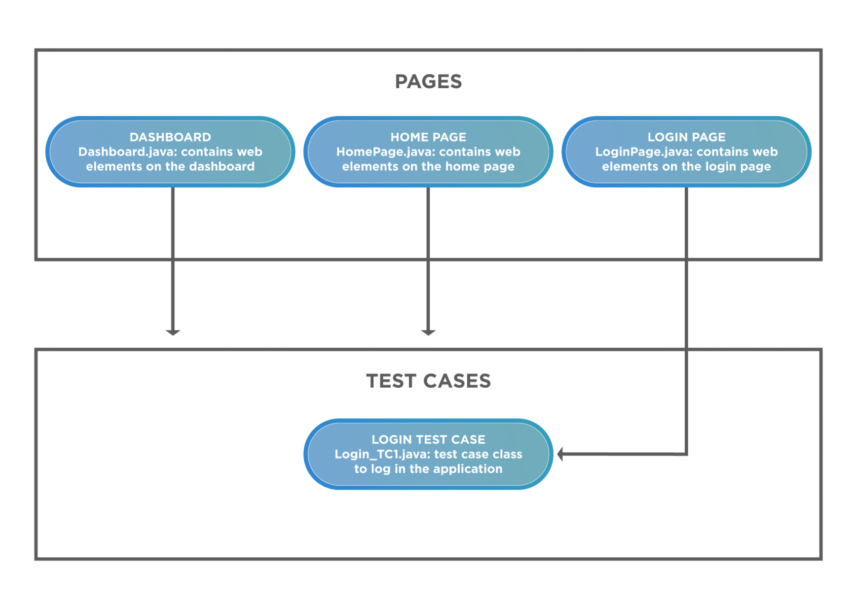
Fig. 5 POM framework

Page Object Model (POM)
The Page Object Model is a Selenium design pattern where each page of the application under test is represented as a separate Java class containing its element locators and interaction methods. Its application during the internship included:
- Creating dedicated page classes for the Amazon Homepage, Search Results Page, and Sort functionality
- Creating page classes for the Practo Hospital Search Page, Diagnostics Page, and Corporate Wellness Form
- Using @FindBy annotations with PageFactory for cleaner element initialization
- Separating test logic from page interaction logic, making scripts modular and easy to maintain

Fig. 5 Logo of Cucumber

BDD Cucumber
Cucumber is a Behavior Driven Development framework that allows test scenarios to be written in Gherkin syntax — Given, When, Then — making them readable by both technical and non-technical stakeholders. During the internship it was applied to:
- Write Feature files describing the Practo test scenarios in plain English
- Implement Step Definition classes in Java mapping each Gherkin step to Selenium actions
- Use scenario outlines and example tables for parameterized test execution
- Generate Cucumber HTML reports for sharing test results with non-technical team members
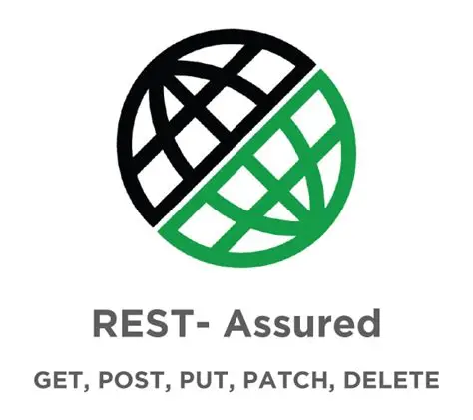
Fig. 6 Logo of REST & Postman

REST Assured and POSTMAN
- POSTMAN — Used for manual API exploration, sending HTTP requests, and validating responses before automation
- REST Assured — Used to automate API validations in Java, including:
  - HTTP GET, POST, PUT, DELETE request execution
  - Status code validation
  - JSON response body assertions using JSONPath
  - Response header and schema validation

Jenkins, Maven, and Git
- Git — Distributed version control for managing source code, branching, and team collaboration
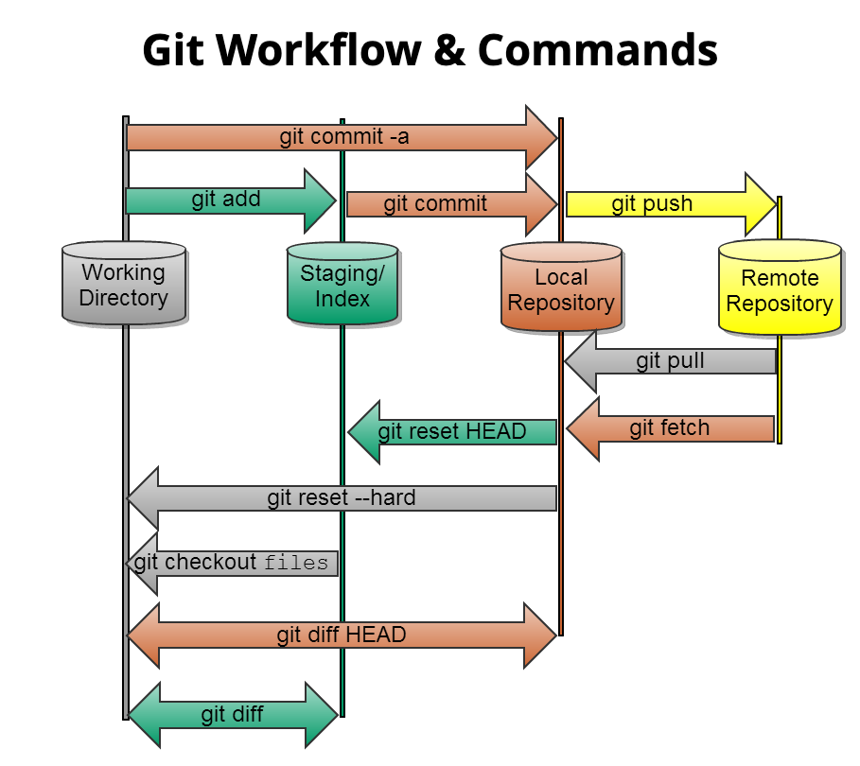
Fig.7 GIT workflow and commands
- Maven — Build automation tool managing project dependencies via pom.xml and handling the full build lifecycle
- Jenkins — CI/CD automation server used to:
  - Trigger automated TestNG test suites on every code push
  - Generate and publish test execution reports
  - Integrate with Maven for build management and Git for source control

Fig. 8 Logo of Jenkins

Eclipse IDE and Azul JDK 17
- Eclipse IDE — Primary development environment for writing, debugging, and executing all Java and Selenium code
- Azul JDK 17 — Java Development Kit providing the runtime environment with full support for modern Java features
Docker
Docker was used in the context of Selenium Grid to:
- Containerize browser instances (Chrome and Firefox) for parallel test execution
- Eliminate manual browser and driver configuration across different machines
- Enable consistent test execution environments regardless of the host operating system
Tekstac and Udemy
- Tekstac — Cognizant's internal platform for hands-on coding exercises with automated evaluation
- Udemy — Self-paced video learning platform with assigned courses on Java, Selenium, and Cucumber forming the theoretical backbone of the Flipped Classroom model

Technical Application

Object-Oriented Framework Design
- Designed the automation framework following OOP principles — base test classes using inheritance, page classes using encapsulation, and utility methods using abstraction
- Created a BaseTest class containing WebDriver initialization and teardown logic, extended by all test classes to avoid code duplication
- Used the Factory pattern for WebDriver instantiation to support multiple browser configurations from a single entry point
Selenium with Page Object Model
- Implemented POM across both projects with clearly separated page and test layers
- For Amazon — page classes for HomePage, SearchResultsPage, and SortHandler
- For Practo — page classes for HospitalSearchPage, DiagnosticsPage, and CorporateWellnessPage
- Used PageFactory.initElements() for lazy initialization of web elements, improving z
Dynamic Element Handling
- Applied Dynamic XPath with contains(), starts-with(), and following-sibling:: axes to locate elements with unstable attributes
- Used WebDriverWait with ExpectedConditions for explicit synchronization:
  - visibilityOfElementLocated() for elements that load asynchronously
  - elementToBeClickable() before performing click actions
  - alertIsPresent() before switching to JavaScript alerts in the Practo project
Data-Driven Testing
- Implemented a reusable ExcelReader utility class using Apache POI to read test data from .xlsx files
- Connected the ExcelReader to TestNG's @DataProvider to feed multiple input combinations into Selenium scripts
- Stored search keywords, expected result counts, filter combinations, and form field values in Excel, completely decoupling test data from test logic
Alert and Window Management
- Used driver.switchTo().alert().getText() to capture and validate the Corporate Wellness warning message in the Practo project
- Managed multiple browser windows using driver.getWindowHandles() and iterator-based switching logic
- Stored the parent window handle before triggering any new window to ensure reliable navigation back to the main context
CI/CD Pipeline
- Configured a Jenkins freestyle project pointing to the Git repository
- Used Maven goals (clean test) in the Jenkins build step to trigger the TestNG suite
- Configured post-build actions to publish TestNG and Surefire HTML reports directly in the Jenkins dashboard
- Set up build triggers to automatically run the full test suite on every Git push

3.4 Challenges Faced
- Environment Configuration
  - Resolved version compatibility conflicts between Selenium 4.15.0, TestNG 7.4.0, Azul JDK 17, and browser driver versions
  - Configured WebDriverManager to automatically manage driver binaries, eliminating manual driver path setup
- Dynamic UI on Amazon
  - Amazon's frequently changing UI caused locators to break between test runs
  - Resolved by writing attribute-independent XPath using contains() and text() functions rather than relying on specific class names or IDs
- Non-Standard Dropdown Handling
  - The Sort By dropdown on Amazon was not a standard HTML select element, making the Selenium Select class unusable
  - Resolved by clicking the dropdown container, waiting for the options list to appear, iterating through WebElements, and clicking the target option by text match
- Multi-Filter Validation on Practo
  - Applying multiple simultaneous filters (24/7, Parking, Rating > 3.5) and ensuring all were correctly reflected in results required careful chaining of explicit waits and post-filter result validation
- Alert Timing
  - The Corporate Wellness alert did not appear immediately after form submission, causing NoAlertPresentException in initial runs
  - Resolved using ExpectedConditions.alertIsPresent() with a defined timeout threshold
- Window Handle Management
  - Losing track of parent window handles during multi-window navigation caused test failures
  - Resolved by storing the parent handle in a variable before any new window was triggered and restoring it explicitly after child window tasks were complete
- Jenkins Pipeline Setup
  - Configuring Jenkins to correctly resolve Maven project structure, locate the TestNG XML suite, and publish reports required careful workspace path configuration and environment variable set

CHAPTER 4: Contribution to the Organization

During the internship at Cognizant under the QEA program, several meaningful contributions were made to the organizational objectives of the GenC learning initiative and the broader Quality Assurance practice.

4.1 Mini Project Development
As part of the Interim Project Evaluation, an individual Mini Project was developed that simulated a real-world web application testing scenario. The project involved creating a Selenium-based test automation framework using the Page Object Model, incorporating TestNG for test management and Apache POI for data-driven testing. The project demonstrated the ability to independently design and implement a structured test suite from scratch.
Mini Project: Online Mobile Search (Amazon)
The mini project was an individual assignment undertaken as part of the Interim Evaluation. The objective was to automate the mobile phone search functionality on Amazon India (https://www.amazon.in) retrieving smartphones priced under Rs. 30,000, sorted by Newest Arrivals, and extracting the top 5 non-sponsored results with their prices.

Project Structure
The project was built using a clean, layered Maven-based architecture in Eclipse IDE
- browserImplementation — handles browser instantiation for Chrome, Firefox, and Edge
- configReader — reads all locators and test data from a properties file, keeping the framework config-driven
- pages — Page Object Model classes for HomePage and SearchPage
- utils — ExtentReports HTML report generation and automatic screenshot capture
- testcases — TestNG test class containing all 6 test methods in execution sequence

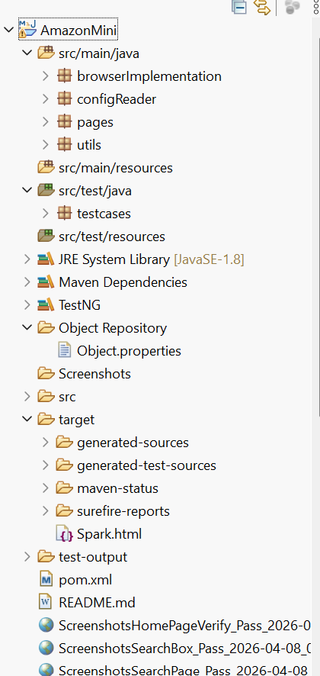
Fig. 9 File Structure
BrowserFactory.java — Multi-Browser Support
The BrowserFactory class was designed to support multiple browsers from a single configurable entry point, eliminating hardcoded browser references from test scripts:
java
public class BrowserFactory {

private WebDriver driver;

public WebDriver chromeLaunch() {
driver = new ChromeDriver();
return driver;
}

public WebDriver Launch_Edge() {
return driver = new EdgeDriver();
}
}
This approach allows switching browsers simply by changing the method call in the test setup, without modifying any test logic.
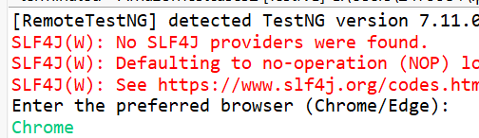
Fig. 10 Browser switching

Fig. 11 HomePage Launched and verified

ObjectReader.java — Config-Driven Locator Management
All element locators, URLs, expected values, and test data were externalized into an Object.properties file and read at runtime through the ObjectReader class. This completely decoupled test logic from test data:
java
public ObjectReader() throws IOException {
pro = new Properties();
String projectDir = System.getProperty("user.dir");
FileInputStream fis = new FileInputStream(
projectDir + "/Object Repository/Object.properties");
pro.load(fis);
}

public String getBaseUrl() {
return pro.getProperty("BaseUrl");
}

public String getSearchKeyValue() {
return pro.getProperty("Amazon.Search.Key");
}

public String getSortListResultProperty() {
return pro.getProperty("Amazon.SearchPage.Sortlist.resultVerify.text");
}
Any change in a locator or expected value required updating only the properties file, not the Java code — a key maintainability advantage of this approach.

HomePage.java — Page Object for Amazon Homepage
The HomePage class encapsulated all interactions with the Amazon homepage, including URL retrieval, title verification, search box location, and search execution:
java
public class HomePage {

private WebDriver driver;
private ObjectReader or;

public HomePage(WebDriver driver) throws IOException {
this.driver = driver;
or = new ObjectReader();
}

public String getHomeUrl() {
return or.getBaseUrl();
}

public String verify_Title() {
return or.getHomeTitle();
}

public WebElement searchBoxLocate() {
return driver.findElement(By.id(or.getSearchObject()));
}

public void searchProduct(WebElement searchBox) {
searchBox.sendKeys(or.getSearchKeyValue());
driver.findElement(By.id(or.getSearchButtonObject())).click();
}
}
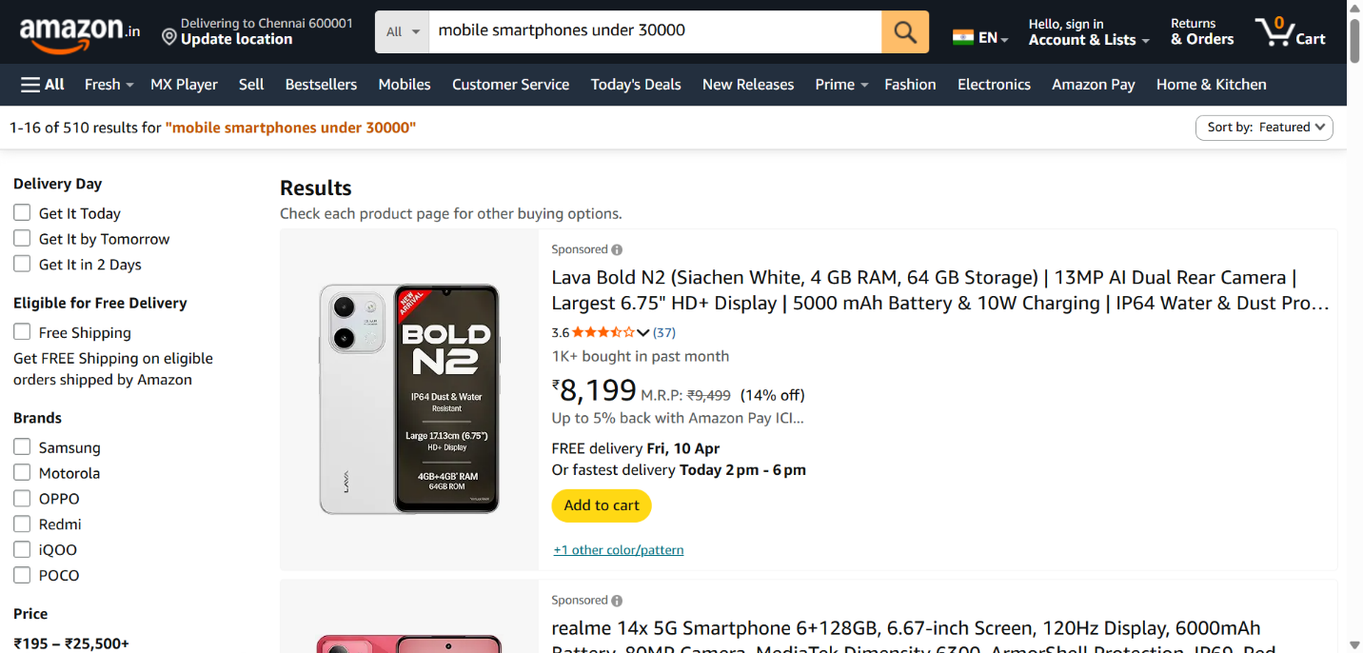
Fig. 12 Navigating searchbar and fetching result

SearchPage.java — Top 5 Non-Sponsored Products Extraction
The most technically complex method in the project was getTop5Products(), which used JavascriptExecutor for smooth scrolling, filtered out sponsored listings, and extracted product names and prices into a LinkedHashMap:
java
public Map<String, String> getTop5Products() {

WebDriverWait wait = new WebDriverWait(driver,
java.time.Duration.ofSeconds(10));
wait.until(ExpectedConditions.presenceOfAllElementsLocatedBy(
By.xpath(or.getSearchResultObject())));

JavascriptExecutor js = (JavascriptExecutor) driver;
List<WebElement> items = driver.findElements(
By.xpath(or.getSearchResultObject()));

Map<String, String> topProducts = new LinkedHashMap<>();

for (WebElement item : items) {
if (topProducts.size() >= or.getTopProductsCount()) break;

try {
js.executeScript(
"arguments[0].scrollIntoView({behavior:'smooth',
block:'center'});", item);

// Skip sponsored listings
boolean isSponsored = !item.findElements(
By.xpath(or.getSponsoredLabelObject())).isEmpty();
if (isSponsored) continue;

String name = item.findElements(
By.xpath(or.getProductNameObject()))
.get(0).getText().trim();

String price;
try {
price = or.getProductPricePrefix() + item.findElement(
By.xpath(or.getProductPriceObject())).getText().trim();
} catch (NoSuchElementException e) {
price = or.getProductPriceFallback();
}

topProducts.put(name, price);

} catch (Exception e) {
System.out.println("Skipped item: " + e.getMessage());
}
}
return topProducts;
}

AmazonTestcases.java — TestNG Test Execution Flow
The test class used TestNG's dependsOnMethods to enforce a strict execution sequence, where each test built on the result of the previous one. ExtentReports was integrated to generate an HTML report with embedded screenshots for each test step:
java
@BeforeClass
public void beforeClass() throws IOException, InterruptedException {
b = new BrowserFactory();
driver = b.chromeLaunch();
driver.manage().window().maximize();
sp = new SearchPage(driver);
h = new HomePage(driver);
sc = new ScreenShot(driver);
w = new WebDriverWait(driver, java.time.Duration.ofSeconds(10));
rg = new Report();
test = rg.reportGenerator();
}

@Test(priority = 0)
public void HomePageVerify() throws InterruptedException, IOException {
ExtentTest home = test.createTest("This is HomePage Report");
driver.get(h.getHomeUrl());
String expectedResult = h.verify_Title();
w.until(ExpectedConditions.titleIs(expectedResult));
Assert.assertEquals(driver.getTitle(), expectedResult);
}

@Test(dependsOnMethods = {"HomePageVerify"})
public void SearchBox() throws IOException {
WebElement searchBox = h.searchBoxLocate();
w.until(ExpectedConditions.visibilityOf(searchBox));
h.searchProduct(searchBox);
}

@Test(dependsOnMethods = {"SearchPageValidate"})
public void SearchPageSort() throws IOException {
WebElement sort = sp.getSortlist();
sort.click();
WebElement sortNew = sp.getSortlistNewestArrival();
sortNew.click();
String actual = sp.getActualSortlistResult();
String expected = sp.getExpectedSortListResult();
Assert.assertEquals(actual, expected);
}

@Test(dependsOnMethods = {"SearchPageSort"})
public void GetTop5Phones() throws IOException {
Map<String, String> top5 = sp.getTop5Products();
int i = 1;
for (Map.Entry<String, String> entry : top5.entrySet()) {
System.out.println(i++ + ". " + entry.getKey()
+ " - " + entry.getValue());
}
Assert.assertEquals(top5.size(), 5);
}

@AfterClass
public void afterClass() {
driver.quit();
test.flush();
}

4.2 Hackathon Project Contribution During the Final Evaluation phase, active contributions were made to the group Hackathon Project. This involved collaborating with team members in an Agile fashion to divide testing responsibilities, develop automated test scripts, integrate tests into a CI/CD pipeline using Jenkins, and present findings to BU SME evaluators. The group project reinforced teamwork, communication, and accountability under real delivery conditions.

4.3 Adoption of QEA Best Practices Throughout the internship, best practices advocated by the QEA service line were actively adopted, including writing clean, modular, reusable test code following the POM pattern; implementing data-driven testing using Apache POI; applying assertion-based validation; using explicit waits to handle asynchronous elements; and maintaining organized test repositories on Git.

4.4 Knowledge Contribution Active participation in peer learning during guided practice sessions contributed to a collaborative learning environment. Sharing approaches to solving Tekstac hands-on exercises and debugging Selenium scripts with fellow interns fostered collective knowledge growth within the cohort.

Overall Impact
My contributions helped SeedsAI unlock new product verticals, improve system performance, and scale AI usage securely. The scalable calling infrastructure and fast transcription pipelines opened up enterprise communication opportunities. Automation via MCP integrations made the platform smarter and more dynamic. AI governance features brought structure to innovation, and the DocChat system expanded AI into document-heavy workflows. These features not only strengthened SeedsAI’s technical backbone but also helped establish it as a trusted AI integration and deployment partner for enterprises, with a clear focus on control, compliance, and cost-efficiency.

CHAPTER 5: Learning and Development

The internship at Cognizant Technology Solutions under the GenC QEA program provided comprehensive exposure across technical, behavioral, and professional dimensions. The following sections document the key learnings acquired over the course of the program.
5.1 Technical Skills Acquired
Core Java and Object-Oriented Programming
- Object-Oriented Design in Practice
  - Applied encapsulation in Page Object Model classes — all WebElement locators declared as private, exposed only through public interaction methods
  - Used inheritance to build a BaseTest class containing WebDriver initialization, WebDriverWait setup, and @AfterClass teardown — extended by all test classes to eliminate code duplication
  - Applied polymorphism in reusable utility methods capable of handling different WebElement types through a common interface
  - Used abstraction to define generic browser launch behavior in BrowserFactory, with specific implementations for Chrome, Firefox, and Edge
- Collections Framework
  - Used LinkedHashMap in the Amazon project to store top 5 product names and prices while preserving insertion order
  - Used ArrayList to collect and store hospital names and city names extracted from the Practo website
  - Applied iterator-based traversal for processing window handle sets during multiple browser window switching in the Practo project
  - Used List with enhanced for-loops and stream pipelines for filtering and processing web element collections
- Java 8 Features
  - Applied Lambda Expressions to simplify anonymous class implementations in event handling and collection processing
  - Used Stream API with filter(), map(), and collect() operations to process and transform lists of WebElements and extracted text values
  - Applied Optional to safely handle potentially null values returned from element searches, avoiding NullPointerExceptions in edge cases
- Exception Handling
  - Implemented specific catch blocks for NoSuchElementException, TimeoutException, StaleElementReferenceException, and NoAlertPresentException
  - Used try-catch-finally blocks in test methods to ensure screenshots were captured on both pass and fail outcomes
  - Learned to distinguish between hard assertions (Assert.assertEquals) that stop execution and soft assertions that allow tests to continue after a failure
- JDBC and SQL
  - Established database connections using DriverManager.getConnection() with JDBC URL, username, and password parameters
  - Executed SELECT, INSERT, UPDATE, and DELETE queries using PreparedStatement for parameterized, injection-safe query execution
  - Processed ResultSet objects using while(rs.next()) iteration to extract and validate query output
  - Applied SQL concepts including joins, subqueries, GROUP BY, HAVING, and aggregate functions in hands-on exercises

Selenium WebDriver
- WebDriver Architecture and Setup
  - Understood the direct communication model of Selenium 4 — WebDriver communicates natively with browser drivers without requiring an intermediate Selenium RC server
  - Configured ChromeDriver, FirefoxDriver, and EdgeDriver instances through the BrowserFactory class
  - Used driver.manage().window().maximize() and driver.manage().timeouts() for standard browser configuration on launch
- Element Location Strategies
  - Applied ID, Name, ClassName, TagName, and LinkText locators for straightforward element identification
  - Used CSS Selectors for faster element lookup using attribute and class-based patterns
  - Built Dynamic XPath expressions using:
    - contains() — for partial attribute value matching
    - starts-with() — for elements with dynamically generated IDs sharing a common prefix
    - text() — for locating elements by their exact visible text content
    - following-sibling:: and parent:: axes — for navigating DOM relationships when direct locators were unavailable
- Synchronization Techniques
  - Applied ImplicitWait globally for baseline element load tolerance
  - Used ExplicitWait with WebDriverWait and ExpectedConditions for precise, condition-based synchronization:
    - visibilityOfElementLocated() — waiting for elements to appear in the DOM and be visible
    - elementToBeClickable() — ensuring elements were interactive before performing click actions
    - presenceOfAllElementsLocatedBy() — waiting for a full list of elements to load before iterating
    - alertIsPresent() — used specifically in the Practo Corporate Wellness scenario before switching to the alert
- Advanced Interactions
  - Used JavascriptExecutor to scroll elements into view using scrollIntoView() — critical for extracting product data from Amazon's dynamically loaded result list
  - Handled JavaScript alert popups using driver.switchTo().alert().getText() and .accept() in the Practo project
  - Managed multiple browser windows using driver.getWindowHandles(), storing the parent handle in a variable and switching to child windows using an iterator
  - Used Actions class for hover, drag-and-drop, and keyboard interactions in hands-on exercises

Page Object Model (POM) Framework
- Framework Architecture
  - Designed a two-layer framework — a pages layer containing page classes with locators and interaction methods, and a testcases layer containing TestNG test scripts that consumed the page classes
  - Created a dedicated configReader layer using ObjectReader.java to externalize all locators and test data into an Object.properties file, making the framework fully config-driven
  - Built a utils layer containing ScreenShot.java for automatic screenshot capture and Report.java for ExtentReports HTML report generation
- Page Classes Implemented
  - HomePage.java — encapsulated Amazon homepage URL retrieval, title verification, search box location, and search execution
  - SearchPage.java — encapsulated search results text validation, sort dropdown interaction, result verification, and top 5 product extraction
  - Used PageFactory.initElements() in page class constructors for lazy initialization of WebElements annotated with @FindBy
- Config-Driven Design
  - All element locators (XPath, ID, CSS), expected values, URLs, and test parameters stored in Object.properties
  - ObjectReader.java loaded the properties file using FileInputStream and exposed each property through dedicated getter methods
  - This design meant that any UI change in the application required updating only the properties file — not a single line of Java test code needed modification

TestNG Framework
- Annotations and Execution Control
  - Used @BeforeClass and @AfterClass for WebDriver setup and teardown at the test class level
  - Used @BeforeMethod and @AfterMethod for pre and post actions at the individual test method level
  - Applied @Test(priority=0) for setting explicit execution order across independent tests
  - Used @Test(dependsOnMethods={}) to enforce sequential dependency — SearchBox could only run after HomePageVerify passed, SearchPage after SearchBox, and so on through all 6 test methods in the Amazon project
- Data-Driven Testing
  - Used @DataProvider to supply multiple input data sets to a single test method
  - Connected @DataProvider to an Apache POI ExcelReader utility to read test data rows from .xlsx files at runtime
  - This approach allowed the same test method to execute across multiple data combinations without any code changes
- Reporting
  - Integrated ExtentReports with TestNG to generate Spark HTML reports after each test run
  - Used ExtentTest.pass(), .fail(), and .addScreenCaptureFromPath() to log test outcomes and attach screenshots directly in the report
  - Configured TestNG XML suite files to control which test classes and methods were included in each execution run

Apache POI
- Created a reusable ExcelReader utility class using XSSFWorkbook and XSSFSheet to read .xlsx files
- Used getRow() and getCell() methods to navigate to specific rows and columns in the Excel sheet
- Applied getCellType() checks to handle cells containing strings, numbers, and boolean values correctly
- Connected the ExcelReader output to TestNG's @DataProvider annotation for seamless data-driven test execution
- Used XSSFWorkbook write operations to log test results back into the Excel sheet after execution

BDD Cucumber
- Framework Structure
  - Wrote Feature files in Gherkin syntax using Given-When-Then format to describe test scenarios in plain English
  - Created Step Definition classes in Java that mapped each Gherkin step to a corresponding Selenium action using @Given, @When, @Then annotations
  - Used Scenario Outline with Examples tables to run the same scenario across multiple data sets without duplicating feature file content
- Practo Scenarios in Gherkin
  - Translated the three Practo test scenarios into feature files — hospital search with filters, diagnostics city extraction, and corporate wellness form validation
  - Each scenario was independently executable through the Cucumber runner class configured with @CucumberOptions
- Reporting
  - Configured Cucumber HTML and JSON plugins in the runner class for dual-format report generation
  - Used the JSON report as input to generate enhanced ExtentReports-compatible Cucumber reports

API Testing — POSTMAN and REST Assured
- POSTMAN
  - Used POSTMAN to manually explore and validate REST API endpoints before automation
  - Created and organized API requests in collections with environment variables for base URL and authentication tokens
  - Validated response status codes, response body content, and response time within POSTMAN's test scripts using JavaScript assertions
- REST Assured
  - Used REST Assured's fluent interface to write automated API tests in Java:
    - given() — for setting request headers, authentication, and body
    - when() — for executing GET, POST, PUT, DELETE HTTP methods
    - then() — for asserting status codes, response body values using JSONPath, and response headers
  - Extracted values from JSON responses using JSONPath expressions and used them as inputs for subsequent API calls — simulating real API workflow automation
  - Integrated REST Assured test classes into the Maven project alongside Selenium tests for unified execution

DevOps — Git, Maven, Jenkins, Docker
- Git
  - Used Git for full version control of both the Amazon and Practo projects throughout the internship
  - Practiced branching strategies — created feature branches for individual development tasks and merged back to main after review
  - Used git add, git commit, git push, git pull, and git log as part of daily workflow
  - Resolved merge conflicts arising from parallel development on the Practo group project
- Maven
  - Managed all project dependencies — Selenium, TestNG, Apache POI, Cucumber, REST Assured, ExtentReports — through the pom.xml file
  - Used Maven lifecycle phases: clean to remove previous build artifacts, compile to build the project, and test to trigger the TestNG suite
  - Understood dependency scope (test, compile, provided) and used the Surefire plugin to configure TestNG XML suite execution through Maven
- Jenkins
  - Created a Jenkins freestyle project linked to the Git repository
  - Configured Maven build steps with goals clean test to trigger full test suite execution on every code push
  - Set up post-build actions to publish TestNG Surefire HTML reports and ExtentReports directly in the Jenkins dashboard
  - Understood the concept of build triggers — SCM polling and webhook-based triggers — for continuous integration
- Docker
  - Pulled official Selenium Grid Docker images for Chrome and Firefox browser nodes
  - Used docker-compose to spin up a Selenium Hub container and connected browser node containers
  - Configured RemoteWebDriver in the test framework to point to the Docker Selenium Grid hub URL instead of a local browser driver
  - Understood how containerization eliminates environment-specific browser configuration issues and enables consistent parallel test execution across machines

GenAI — AI Accelerate Program
- Completed the AI Accelerate module covering fundamentals of Artificial Intelligence and its application in software quality assurance
- Learned how AI can be applied in QA contexts including:
  - Predictive Defect Analysis — using ML models trained on historical defect data to predict which code areas are most likely to fail
  - Intelligent Test Case Generation — using AI to automatically generate test cases from requirements documents and user stories
  - Test Optimization — using AI to prioritize test cases based on risk, code coverage, and historical failure patterns — reducing regression suite execution time
  - Self-Healing Locators — AI-based tools that automatically update broken XPath or CSS locators when the UI changes, reducing framework maintenance effort
- Participated in the AI expert connect session and completed the GenAI Knowledge Check Assessment

5.2 Behavioral and Professional Skills
- Communication
  - Regularly presented test results, project status, and technical approaches to Mr. Mohan Jayabala and BU SMEs during office sessions
  - Articulated technical findings clearly during the Interim and Final video interview evaluations with SME panels
  - Collaborated with team members during the Practo Hackathon project by communicating task ownership, progress updates, and blockers effectively
- Problem Solving and Debugging
  - Developed a structured debugging approach — isolating failing test steps, reading stack traces carefully, checking locator validity using browser developer tools, and applying targeted fixes
  - Learned to distinguish between application bugs and automation script issues — a critical skill for a QA professional
  - Applied root cause analysis when tests failed intermittently due to timing issues, always resolving the underlying cause rather than adding arbitrary sleep statements
- Self-Management and Learner Autonomy
  - The Flipped Classroom model required self-organizing daily learning across Tekstac exercises, Udemy course content, and Eclipse-based practice simultaneously
  - Developed the discipline to complete mandatory Tekstac hands-on submissions on time while also progressing project development in parallel
  - Managed time effectively during the simultaneous pressure of Code Challenge assessments and project delivery deadlines
- Teamwork and Collaboration
  - Divided the three Practo Hackathon scenarios among team members based on individual strengths and bandwidth
  - Conducted peer code reviews within the group — identifying issues in each other's XPath locators and synchronization logic before final submission
  - Contributed to a shared Git repository, managing branches and resolving merge conflicts collaboratively
- Corporate Readiness
  - Internalized Cognizant's four core values — Work as One, Own It, Raise the Bar, and Dare to Innovate — through workshops and their practical application in daily work
  - Participated in leader talks, alumni connect sessions, and talent manager interactions that provided valuable perspective on career growth in the IT industry
  - Developed professional communication etiquette appropriate to a corporate environment — including email communication, meeting participation, and technical presentation standards

5.3 Assessments and Certifications Completed
- Code Challenge (CC) — Java Group 1 and Group 2 — Timed coding assessments testing Core Java problem-solving ability on the Tekstac platform
- Integrated Capability Test (ICT) — Core Java — Comprehensive assessment covering OOP, Collections, Exception Handling, and Java 8 features
- Integrated Capability Test (ICT) — Functional Testing — Assessment covering SDLC, STLC, test case design, and defect lifecycle
- Stage 1 Qualifier and Mock Assessments — Pre-evaluation assessments to gauge readiness before the formal Stage 1 ICT
- Interim Technical Evaluation — Video interview with a BU SME panel assessing Core Java and Selenium fundamentals, including a live code walkthrough of the Amazon Mini Project
- Final Technical Evaluation — Video interview with a BU SME panel assessing the complete automation framework, Practo Hackathon project, DevOps integration, and GenAI knowledge
- GenAI Knowledge Check Assessment — Assessment covering AI fundamentals, applications in QA, and AI Accelerate program learnings

CHAPTER 6: SUMMARY AND CONCLUSION

6.1 Summary
The internship at Cognizant Technology Solutions under the Generation Cognizant (GenC) Quality Engineering and Assurance program was a comprehensive, structured, and deeply technical professional engagement that spanned from 31st January 2025 to 15th May 2025. Conducted in offline mode at Cognizant's office under the mentorship of Mr. Mohan Jayabala, the program provided end-to-end exposure to the tools, methodologies, and practices that define modern software quality engineering.
The key highlights of the internship are summarized below:
Stage 1 — Core Java with SQL
- Built a strong foundation in Core Java covering:
  - Object-Oriented Programming — encapsulation, inheritance, polymorphism, abstraction
  - Collections Framework — ArrayList, LinkedHashMap, HashSet, TreeSet, PriorityQueue
  - Java 8 Features — Streams, Lambda Expressions, Optionals
  - Exception Handling — specific catch blocks, try-catch-finally, custom exceptions
  - JDBC and SQL — database connectivity, PreparedStatement, ResultSet processing, joins, and aggregations
- Completed Code Challenge assessments and the Integrated Capability Test (ICT) for Core Java on the Tekstac platform
Stage 2 — Functional Testing with Selenium Automation
- Progressed from Selenium WebDriver basics to building a complete, production-grade test automation framework incorporating:
  - Page Object Model (POM) with config-driven ObjectReader for locator management
  - TestNG with dependsOnMethods, @DataProvider, and XML suite configuration
  - Apache POI for data-driven testing from Excel files
  - BDD Cucumber with Gherkin feature files and Java step definitions
  - REST Assured and POSTMAN for API automation and manual API validation
  - Jenkins, Maven, and Git for CI/CD pipeline integration
  - Docker for containerized Selenium Grid execution
- Completed ICT for Functional Testing, Interim Technical Evaluation, and Final Technical Evaluation
Amazon Mini Project
- Independently designed and implemented a Maven-based Selenium automation framework with the following components:
  - BrowserFactory for multi-browser support (Chrome, Firefox, Edge)
  - ObjectReader for config-driven locator and test data management
  - HomePage and SearchPage page classes using the Page Object Model
  - ScreenShot utility for automatic screenshot capture on pass and fail
  - ExtentReports integration for HTML report generation with embedded screenshots
- Successfully automated 6 sequential TestNG test methods:
  - HomePageVerify — title validation on Amazon homepage load
  - SearchBox — search keyword entry and submission
  - SearchPage — search results text validation
  - SearchPageValidate — regex-based result count validation
  - SearchPageSort — Newest Arrivals sort selection and verification
  - GetTop5Phones — extraction of top 5 non-sponsored smartphones with prices using JavascriptExecutor and LinkedHashMap
- All test methods passed successfully with auto-generated screenshots confirming each step
Practo Hackathon Project
- Contributed to a group automation project on Practo covering three scenarios:
  - Hospital search with 24/7, Parking, and Rating > 3.5 filters — extracting and displaying qualifying hospital names
  - Diagnostics top cities extraction — storing all city names in a Java List and displaying them
  - Corporate Wellness form validation — filling invalid details, capturing and validating the JavaScript alert warning message
- Applied advanced Selenium concepts including alert handling, multiple window management, and collection-based data extraction
GenAI Module
- Completed the AI Accelerate program covering AI fundamentals, predictive defect analysis, intelligent test case generation, test optimization, and self-healing locators
- Participated in the AI expert connect session and completed the GenAI Knowledge Check Assessment

6.2 Conclusion
The GenC QEA internship at Cognizant Technology Solutions was far more than a training program — it was a genuine professional experience that demanded accountability, technical rigor, and the kind of independent problem-solving that academic coursework rarely requires. Working in an offline corporate environment under the guidance of Mr. Mohan Jayabala and Cognizant's BU SMEs brought a level of professional discipline and industry exposure that has fundamentally shaped my approach to software development and quality assurance.
The key conclusions drawn from this internship are as follows:
- Framework Thinking over Script Writing
  - The most important shift in mindset during this internship was moving from writing individual test scripts to designing a maintainable, scalable automation framework. The Page Object Model, config-driven ObjectReader, and layered Maven project structure taught me that good automation is first and foremost good software engineering — the same principles of modularity, reusability, and separation of concerns apply equally to test code as to production code.
- Configuration Over Hardcoding
  - The ObjectReader pattern used in the Amazon project demonstrated the value of externalizing all test data, locators, and expected values into a properties file. This single architectural decision made the framework resilient to UI changes and eliminated the need to touch Java code for routine test maintenance — a practice I will carry into every automation project going forward.
- Synchronization is the Foundation of Reliable Automation
  - One of the most practically valuable lessons from the internship was understanding that flaky tests are almost always a synchronization problem. Learning to apply WebDriverWait with specific ExpectedConditions — rather than Thread.sleep() — and understanding when to use visibilityOfElementLocated() versus elementToBeClickable() versus alertIsPresent() gave me the tools to write tests that are stable across different network conditions and machine speeds.
- Quality Engineering is a Full-Stack Discipline
  - The breadth of the GenC QEA program — spanning Core Java, Selenium, TestNG, Cucumber, REST Assured, Jenkins, Maven, Git, and Docker — made clear that modern quality engineering is not limited to writing test cases. A quality engineer today is expected to understand the full software delivery pipeline, from code commit to deployment, and to integrate quality checks at every stage. The CI/CD pipeline work with Jenkins was a direct demonstration of this shift-left testing philosophy in practice.
- The Value of Working in a Corporate Environment
  - The offline nature of this internship was a significant advantage. Being physically present at Cognizant's office — attending standups, interacting with SMEs, collaborating with teammates on the Practo project, and presenting work during evaluations — provided a level of professional immersion that remote programs cannot replicate. The experience of being accountable to a team, meeting daily submission targets, and performing under evaluation pressure has directly prepared me for the demands of a full-time professional role.
- GenAI as the Next Frontier in QA
  - The GenAI module introduced a dimension of quality engineering that is rapidly becoming mainstream. AI-driven test optimization, self-healing locators, and predictive defect analysis are not future concepts — they are already being deployed in enterprise QA pipelines. This exposure has motivated me to continue developing my understanding of AI applications in testing beyond the internship.
In conclusion, the internship has equipped me with a robust, production-ready skill set in Java-based test automation, a sound understanding of QA principles and DevOps practices, and the professional competencies required to contribute effectively from day one in a quality engineering role. The experience at Cognizant has not only made me a better technical professional but has also instilled a quality-first mindset that I will bring to every piece of software I am involved with going forward.

CHAPTER 7: SUGGESTIONS FOR THE IMPROVEMENT

Based on observations and challenges encountered during the internship, the following suggestions are offered for improving the GenC QEA program:

- Standardized Environment Setup
  - A significant amount of time was lost resolving version compatibility issues between Eclipse, Azul JDK 17, Selenium, and TestNG during the initial phase
  - Providing a pre-configured Docker container or virtual machine with all required software pre-installed and version-locked would eliminate setup issues and allow learners to focus on learning from day one
- Earlier Introduction of Page Object Model
  - POM was introduced after learners had already written several Selenium scripts without it, resulting in unnecessary refactoring effort
  - Introducing POM as a core design principle before the first Selenium script is written would encourage well-structured framework development from the start
- Deeper Coverage of API Automation
  - REST Assured and POSTMAN were covered briefly towards the end of Stage 2, leaving insufficient time to develop real depth in API automation
  - A dedicated API automation mini project similar to the Amazon Selenium project would provide the necessary hands-on consolidation for this increasingly critical skill
- CI/CD as a Mandatory Project Deliverable
  - Jenkins pipeline integration was practiced as an isolated exercise but was not a required component of the final project submission
  - Making end-to-end CI/CD pipeline deployment mandatory for the final evaluation would ensure every learner gains practical experience running an automated test suite in a real pipeline
- Increased Mentor Accessibility
  - Access to SME mentors during peak project development periods could have been more frequent
  - A structured daily mentor office hour where learners can bring specific technical blockers would reduce time lost waiting for doubt resolution and keep project momentum consistent
- Assessment Preparation Support
  - The Code Challenge and ICT assessments would benefit from clearer advance communication about topics, format, and scope
  - Providing a structured preparation guide with sample questions categorized by topic would allow learners to self-assess readiness and address gaps before formal evaluations
- Recognition of Learning Milestones
  - Introducing stage-completion certificates or digital badges for passing each ICT and completing each stage would add a motivational dimension and give learners tangible credentials to showcase alongside their internship certificate
In summary, the GenC QEA program is a well-structured and genuinely valuable internship. The suggestions above are offered in the spirit of Cognizant's core value — Raise the Bar — and are intended to help the program evolve with the rapidly changing demands of the quality engineering profession.

BIBLIOGRAPHY

[1] Cognizant Technology Solutions, "GenC Learning Journey Guide – Java Engineer Track with Full Selenium Internship (Quality Automation – v3)," Learner Handbook, Version 3, 2024.
[2] Cognizant Technology Solutions, "About Cognizant," https://www.cognizant.com/us/en/about-cognizant.
[3] SeleniumHQ, "Selenium WebDriver Documentation," https://www.selenium.dev/documentation/webdriver/.
[4] TestNG, "TestNG Documentation – Annotations and Configuration,"https://testng.org/doc/documentation-main.html.
[5] Apache Software Foundation, "Apache POI – Java API for Microsoft Documents,": https://poi.apache.org/.
[6] Cucumber Ltd, "Cucumber BDD – Gherkin Reference and Step Definitions," https://cucumber.io/docs/cucumber/.
[7] Rest-assured.io, "REST Assured User Guide," .: https://rest-assured.io/.
[8] Jenkins, "Jenkins User Documentation – Pipeline and Freestyle Projects," https://www.jenkins.io/doc/.
[9] Apache Maven Project, "Maven – Introduction to the Build Lifecycle," https://maven.apache.org/guides/introduction/introduction-to-the-lifecycle.html.
[10] Docker Inc., "Docker Documentation – Getting Started with Containers,"
https://docs.docker.com/get-started/.
[11] Git, "Git Reference Documentation,"https://git-scm.com/doc.
[12] Aventstack, "ExtentReports – Java Documentation," [Online]. https://www.extentreports.com/docs/versions/5/java/
[13] Baeldung, "Introduction to Selenium WebDriver with Java," [Online]. Available: https://www.baeldung.com/java-selenium-with-junit. .

